|  |  |  |  |  |  |
| --- | --- | --- | --- | --- | --- |
|  | Name: | Klasse: | Datum: |  | KV C c |
|  |  | | | | |

1



Lies und schreibe zu den Bildern.

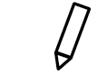

Cabrio

Computer

Cola

Creme



|  |
| --- |
|  |
|  |
|  |

|  |
| --- |
|  |
|  |
|  |



|  |
| --- |
|  |
|  |
|  |

|  |
| --- |
|  |
|  |
|  |

2



Lies und male.

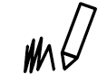

Clown

Comic

Popcorn

Sonnencreme

Eiscreme

Cent